Assessing the Sensitivity of Predicted mRNA Half-life to Synonymous Sequence Variation

Introduction
mRNA half-life is a critical determinant of gene expression, influencing protein abundance independently of transcription rates. The inherent instability of mRNA due to its structure and chemical properties acts as a natural control for expression of genes and subsequent cellular processes. When designing synthetic RNA transcripts or measuring gene expression based on RNA sequencing data, the ability to predict stability or detect changes in stability is useful.
mRNA stability is regulated by multiple-sequence-encoded features, including AU-rich elements (AREs) and miRNA binding sites in the 3’ UTR, as well as secondary structure and codon composition in coding regions (Duan et al., 2013; Mauger et al., 2019; Narula et al., 2019). Recent studies have demonstrated that deep learning models, particularly convolutional neural networks (CNNs), can predict mRNA degradation from sequence features with moderate accuracy (Wayment-Steele et al., 2022; Yaish & Orenstien, 2022). However, these models have primarily focused on 3’ UTR sequences and have not systematically evaluated whether their predictions reflect biologically meaningful features or simply memorized sequence patterns. While experimental work has shown that synonymous codon changes affect mRNA stability through alterations in secondary structure (Mauger et al., 2019), the sensitivity of predictive models to such mutations remains largely unexplored.
We developed a dual-input convolutional neural network to predict mRNA half-life from human transcripts using both sequence-level features and thirteen derived characteristics capturing composition, structure, and regulatory motifs. To determine whether the model learned biologically relevant patterns versus arbitrary sequence dependencies, we systematically tested its sensitivity to synonymous mutations in the coding sequence of CASP9.
I spent about 40 hours on this project in total. I estimate that I spent about 5 hours researching, finding the data, and coming up with my hypothesis, about 30 hours coding and performing analysis, and about 5 hours writing the report. I spent the first workday in class searching for data, the second workday working on processing my data, and the third and fourth workdays starting the report. Most of the time spent on this project was outside class.
Methods
Data Sources and Preprocessing
mRNA half-life data were obtained from a published genome-wide study of human B-lymphoblastoid cell lines by Duan et al. (2013). The dataset contains measurements from seven HapMap cell lines generated using 4sU-labeled nascent RNA. These seven measures were averaged to obtain a single half-life value for each sequence. RNA sequences were obtained from the NCBI RefSeq RNA database and filtered to include only transcripts for which experimentally measured mRNA half-life values were available. Transcripts with missing half-life values or with lengths outside the range of 500-5,000 base pairs were excluded from analysis for consistency. Filtering and preprocessing resulted in 7,704 of the original 10,347 sequences that were used for training and testing.
Sequence Encoding and Feature Construction
RNA sequences were transformed into numerical features representing primary sequence composition and secondary structure for input into the predictive model. For each base, base-pairing probabilities were calculated using the ViennaRNA package (version 2.7.1) under default parameter settings. RNA sequences were represented using one-hot encoding, with four channels for nucleotide identity, a fifth channel for base-pairing probability, and a sixth channel used to mask padding positions. Sequences were padded to a uniform length of 3,500 nucleotides. Sequences shorter than 3,500 nucleotides were zero-padded at the 5’ end, while sequences longer than 3,500 nucleotides were truncated from the 5’ end to retain the 3’ terminal 3,500 nucleotides.
Thirteen additional features were derived for each transcript: total sequence length, GC content, AU content, AU-rich element (ARE) score, presence of a polyadenylation signal, GC content in the 3’ UTR, mean base-pairing probability across the transcript, mean base-pairing probability in the 3’ UTR, open reading frame (ORF) length, ORF-to-transcript length ratio, codon adaptation index (CAI), number of predicted miRNA binding sites, and miRNA site density normalized by UTR length. These features consider composition, structure, and motifs, which all contribute to RNA stability.
ARE score was defined as the count of AUUUA 5-mers per 1,000 bases of transcript sequence. Polyadenylation signal was encoded as a binary feature indicating the presence of AAUAAA or AUUAAA or a close variation of one of them within the final 100 nucleotides of the transcript. GC content in the 3’UTR was computed over the final 500 nucleotides (or the full sequence for transcripts shorter than 500 nucleotides). Mean pairing probability was the average ViennaRNA base-pairing probability across the transcript. 3’ UTR pairing probability was the mean probability over the final 500 nucleotides.
The longest ORF was identified by scanning the transcript for canonical AUG start codons and extending each in-frame until the first stop codon (TAA, TAG, or TGA). Among all start positions, the ORF with maximal length was selected. Only canonical start codons and in-frame stop codons were permitted. CAI was calculated following Sharp and Li (1987) using the standard human codon usage table, where each codon’s relative adaptedness is computed as its frequency divided by the maximum frequency among synonymous codons The geometric mean across all codons yielded the transcript-level CAI.
miRNA binding sites were identified as exact matches to 7-mer seed sequences from the 20 most abundantly expressed human miRNAs across the full transcript (Supplementary Table 1). Overlapping matches were counted, with no allowance for bulges or mismatches. Total site counts and site density per 1,000 bases were used for model features.
Model Architecture and Training
A dual-input neural network was implemented in Keras to predict mRNA half-life from both sequence features and transcript characteristics. The model architecture consisted of two parallel processing pathways that were merged. The sequence pathway processed the padded 3,500 x 6 input tensors through three dilated convolutional layers with 64, 64, and 128 filters respectively, using kernel size 3 and dilation rates of 1, 2, and 4 to capture sequence patterns at multiple scales. Global max pooling was applied to extract the most influential features from the convolutional output.
The feature pathway processed the thirteen derived transcript features through three fully connected layers with 128, 64, and 32 units. Each layer utilized batch normalization and dropout (rates of 0.3, 0.3, and 0.2 respectively) applied after each hidden layer. The outputs from both pathways were concatenated and passed through two additional fully connected layers with 128 and 64 units with dropout rates of 0.5 and 0.4 before a final linear output layer.
Prior to training, all 13 derived features were standardized using z-score normalization based on training set statistics. Target half-life values were log-transformed using log(1+x) and then standardized to have a mean of zero and unit variance. The model was trained using the Adam optimizer with a learning rate of 1e-4 and gradient clipping (norm = 1.0). The loss function was mean squared error. The dataset was split into training (70%), validation (15%), and test (15%) sets. Training proceeded for 40 epochs with a batch size of 32, incorporating early stopping (patience = 10 epochs) and learning rate reduction (factor = 0.5, patience = 5 epochs, minimum learning rate = 1e-6) based on validation loss.
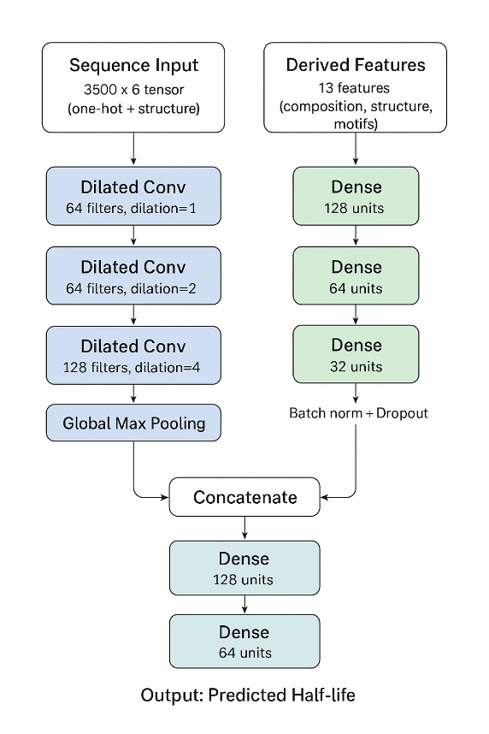
Figure 1. Schematic representation of the dual-input convolutional neural network trained to predict mRNA half-life. Sequence inputs, represented as 3500 x 6 tensors, were passed through three dilated convolutional layers and global max pooling. The thirteen derived features were passed through three dense layers, including batch normalization and dropout. The outputs of these two pathways were concatenated and passed through two more dense layers before outputting the predicted half-life.
Evaluation Metrics
Model performance was evaluated on the test set after training. Predictions and actual half-life values were back-transformed to the original hour scale. Pearson correlation coefficient was used to assess the linear relationship between predicted and observed half-lives, while Spearman correlation coefficient measured the monotonic relationship and robustness to outliers. Mean absolute error (MAE) and mean squared error (MSE) were calculated on the standardized scale during training and validation. Additionally, prediction performance was examined across different error magnitude ranges (< 1 hour, 1-2 hours, 2-5 hours, and >= 5 hours) and stratified by half-life ranges to assess model performance on short-lived versus long-lived transcripts.
Synonymous Mutation Analysis
To assess the model’s sensitivity to synonymous codon changes (i.e. silent point mutations) in the coding region, a systematic mutagenesis analysis was performed on the human CASP9 transcript (NM_001229, 2,808 nucleotides, measured half-life = 4.96 hours). The longest ORF was identified using the methodology described previously, spanning positions 16-1,266. A 300-nucleotide region was selected within the central position of the coding sequence (positions 592-891), adjusted to maintain codon boundaries.
Synonymous mutations were introduced by replacing codons with alternative codons encoding for the same amino acid, without introducing stop codons. For each original codon within the mutation region, a synonymous alternative was randomly selected from all available synonymous codons for that amino acid. Three mutation densities were tested: 10, 50, and 100 synonymous substitutions per mutant sequence. Twenty-five independent mutant sequences were generated at each density level, yielding 75 total mutant sequences plus the wildtype reference (Supplementary Table 2).
All mutant sequences underwent the same preprocessing steps as the training data, including one-hot encoding, base-pairing probability calculation, feature calculation, and normalization using parameters from the training set. Half-life predictions were generated for the wildtype and all 75 mutants using the trained neural network model. Predictions were back-transformed from the standardized log scale for interpretation. To quantify the effect of synonymous mutations on predicted stability, the change in predicted half-life relative to wildtype was calculated for each mutant, expressed in both absolute hours and percent change.
Statistical analysis included correlation between mutation count and stability change, one-sample t-tests comparing mutants to wildtype, and analysis of variance (ANOVA) across mutation density groups. Additionally, correlations between changes in individual features (relative to wildtype) and changes in predicted-half life were examined to identify which sequences properties were most strongly associated with predicted stability differences.
Results
Model Performance
After training on 5,392 sequences, the model was evaluated on 1,156 held-out test sequences (Figure 2). The model achieved a Pearson correlation of 0.227 (Spearman ρ = 0.245) between the predicted and observed half-lives. Mean squared error was 0.890 and mean absolute error was 0.717 on the standardized scale, corresponding to a mean absolute error of 2.06 hours on the original scale. The median absolute error of the model was 1.46 hours. The mean actual half-life was 6.34 hours compared to a mean predicted half-life of 5.62 hours.
428 predictions (36.9% of the test set) were within one hour of the actual half-life. 305 predictions (25.9%) were within 1-2 hours, 321 predictions (28.6%) were within 2-5 hours, and 102 predictions (8.6%) had errors greater than five hours. For the 17 transcripts with actual half-lives greater than 15 hours, the mean and median error were 12.0 and 11.52 hours respectively. The Pearson correlation coefficient for this subset was 0.167. The mean predicted half-life for these long-lived transcripts was 5.80 hours, while the actual mean was 17.8 hours, indicating systematic underprediction of extreme values.
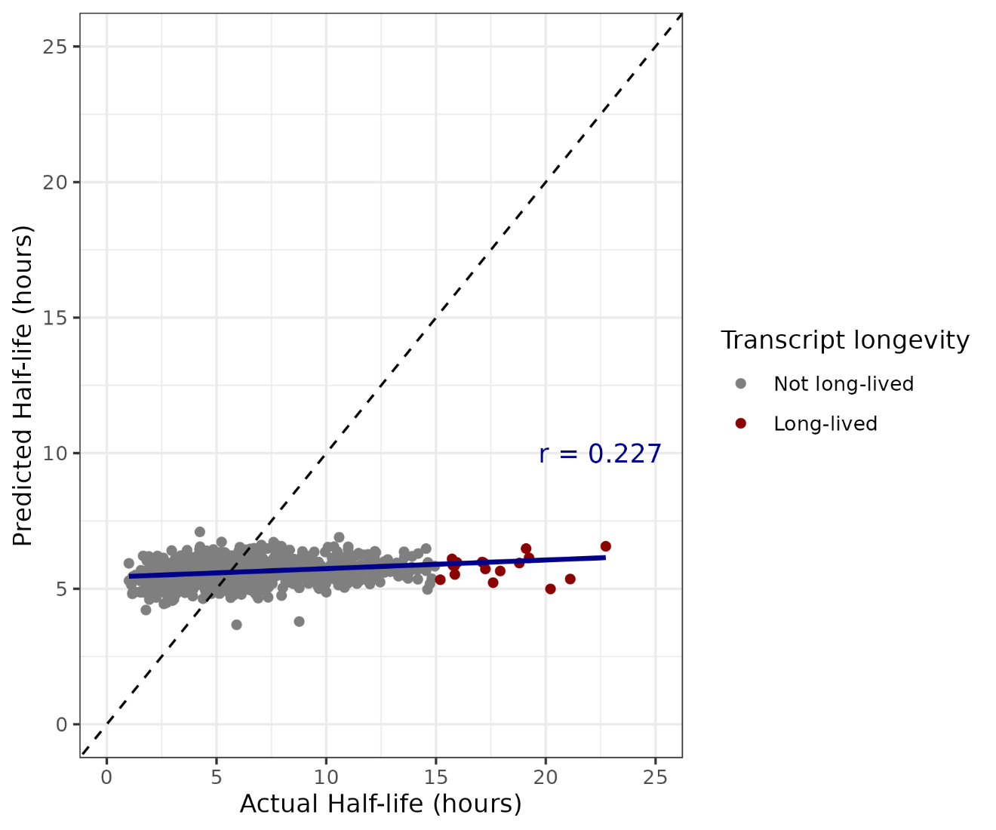
Figure 2. Predicted mRNA half-life values of 1,156 transcripts from the trained model plotted against experimentally measured half-lives. Points are colored by transcript longevity. The dashed line indicates the identify line (y = x), and the solid line shows the best-fit linear regression. The Pearson correlation coefficient (r = 0.227) indicates a weak but positive association between predicted and actual half-life.
To understand which features were associated with the predicted stability, the correlations between the thirteen features and the predicted stability were observed (Figure 3). Sequence length (r = -0.643), ORF length (r = -0.569), and miRNA sites (r = -0.426) showed the strongest negative correlation with predicted half-life, while CAI (r = 0.521) showed the strongest positive correlation. GC content in the 3’ UTR (r = 0.223) and ARE score in the 3’ UTR (r = -0.207) showed moderate correlation with predicted half-life. The rest of the features minimally correlated to transcript stability, where |r| < 0.1.
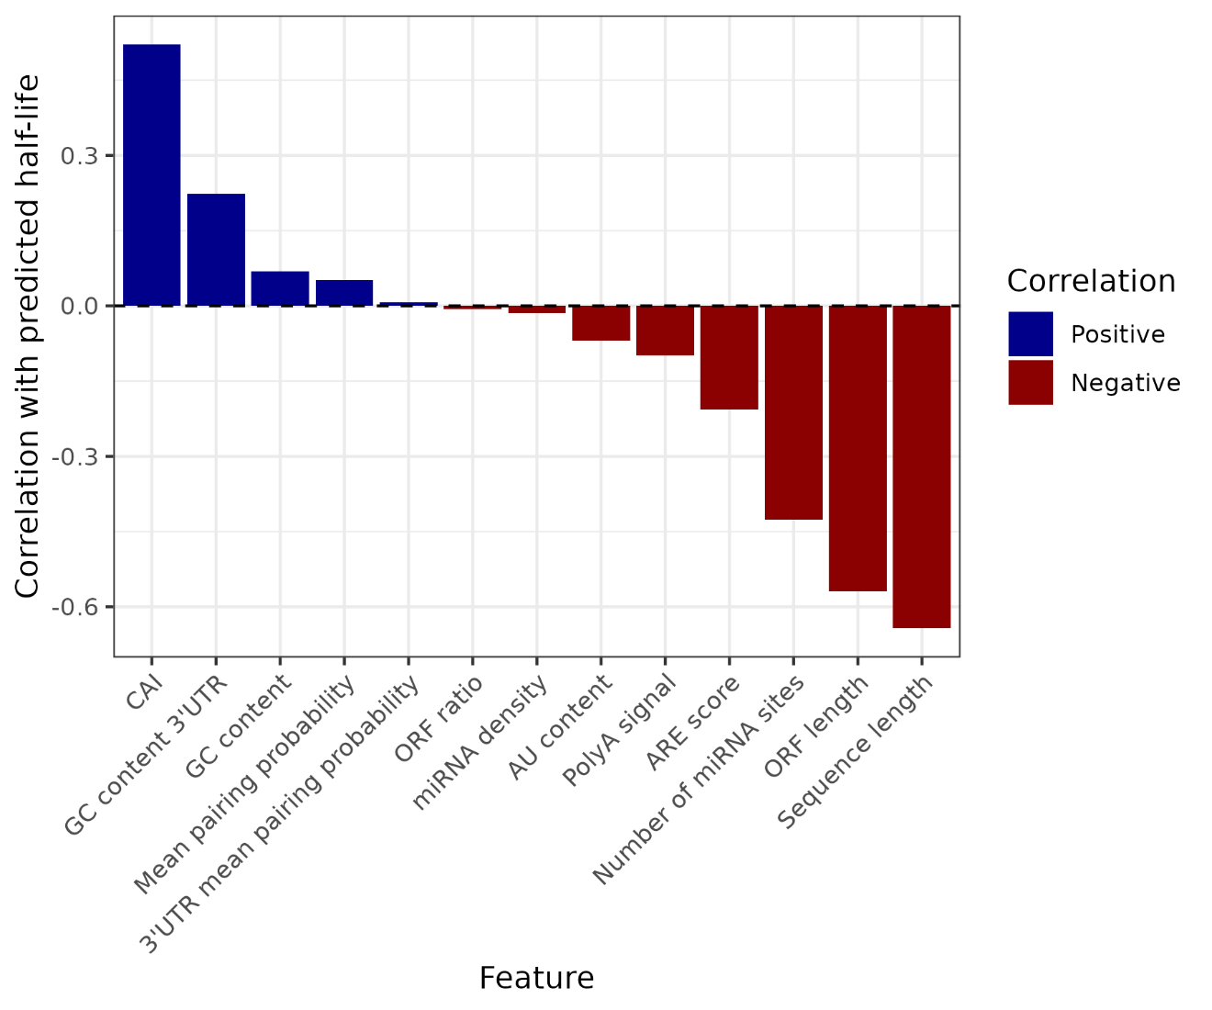
Figure 3. Pearson correlation coefficients between individual sequence-driven features and predicted stability for tested mRNA transcripts. Features are ordered by correlation magnitude. Positive correlations (blue) indicate associations with increased stability, while negative correlations (red) indicate association with reduced stability.
Synonymous Mutation Sensitivity
The model predicted a half-life of 5.34 hours for the wildtype CASP9 sequence (actual half-life = 4.96 hours), yielding a prediction error of 0.38 hours. Across all 76 sequences, including wildtype and 75 mutants, predictions ranged from 5.06 to 5.47 hours with a standard deviation of 0.078 hours.
Mutants with 10 synonymous mutations showed a mean predicted half-life of 5.35 hours (range 5.31-5.39 hours), representing a mean change of 0.01 hours (0.1%) from wildtype. Mutants with 50 mutations had a mean predicted half-life of 5.30 hours (range 5.06-5.46 hours; mean change: -0.04 hours, -0.7%). Mutants with 100 mutations showed a mean predicted half-life of 5.40 hours (range 5.18-5.47 hours; mean change: +0.05 hours, +1.0%) (Figure 4).
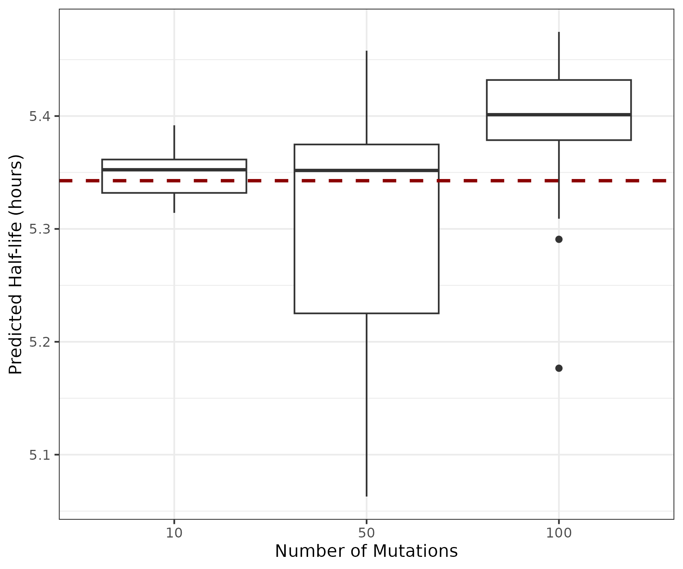
Figure 4. Predicted half-life distributions for CASP9 following introduction of synonymous mutations within a 300 bp region of the coding sequence. Boxplots show predictions for 25 independently generated mutants at each mutation level (10, 50, or 100 synonymous substitutions). The dashed horizonal line indicates the predicted half-life of the wildtype transcript.
A one-sample t-test indicated that mutant predictions were not significantly different from the wildtype prediction (mean difference = -0.0066 hours, p = 0.478). However, ANOVA revealed significant differences among mutation count groups (p = 1.59e-4). Linear regression showed a statistically significant but biologically insignificant relationship between mutation count and predicted half-life change (slope = 5.72e-4 hours per mutation, R^2 = 0.0698, p = 0.022). A quadratic model provided better fit (R^2 = 0.216, p = 4.78e-4) but the effect size remained minimal. The average effect per synonymous mutation was 0.0001 hours (0.002% of wildtype half-life). The maximum observed change across all mutants was -0.28 hours (-5.24% of wildtype), observed in mutant_36 with 50 mutations.
To understand which sequence features were associated with the observed stability changes, the correlations between changes in the 13 derived features relative to wildtype and changes in predicted half-life were observed (Figure 5). Total miRNA sites (r = -0.784) and miRNA density (r = -0.784) showed the strongest negative correlations, while CAI (r = 0.586) showed the strongest positive correlation. Mean pairing probability (r = -0.275), AU content (r = 0.263), and GC content (-0.263) showed moderate correlations. Notably, several features remained unchanged across all mutants, including sequence length, ARE score, polyadenylation signal, GC content in the 3’ UTR, mean pairing probability in the 3’ UTR, and ORF-related metrics, as these features are unchanged under synonymous mutations.
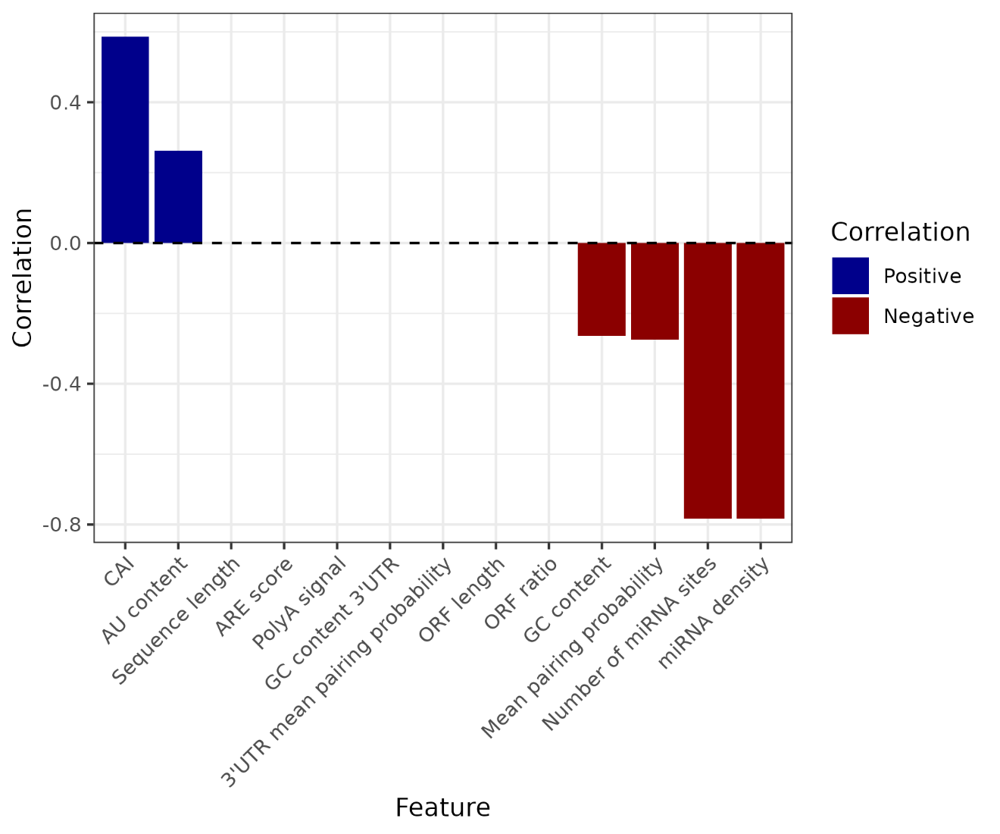
Figure 5. Pearson correlation coefficients between individual sequence-driven features and predicted mRNA half-life across mutated CASP9 transcripts. Features are ordered by correlation magnitude. Positive correlations (blue) indicate associations with increased stability, while negative correlations (red) indicate association with reduced stability.
Discussion
We developed a dual-input convolutional neural network to predict mRNA half-life from 7,704 human transcripts and used it to examine the predicted effect of synonymous mutations on the half-life of CASP9. The trained model achieved moderate correlation between predicted and observed half-lives (Pearson r = 0.227, Spearman p = 0.245) on the test set, though it systematically underpredicted long-lived mRNAs (> 15 hours). To assess model sensitivity to synonymous codon changes, we generated 75 CASP9 mutants with 10, 50, or 100 synonymous substitutions. Synonymous mutations produced minimal changes in predicted half-life (maximum change: 5.84%), and mutants did not significantly differ from wildtype (p = 0.478).
The moderate correlation (r = 0.227) between predicted and observed half-life values suggests that sequence-encoded features capture meaningful but incomplete information about mRNA stability. mRNA stability is influenced by both cis-acting elements (sequence-encoded features) and trans-acting factors such as RNA-binding proteins, decay machinery, and cellular context. This model, trained only on cis-acting elements, successfully learned biologically meaningful patterns including sequence length (r = -0.643), ORF length (r = -0.569), and CAI (r = 0.521). But these features explain only a portion of the variance in mRNA half-life.
The minimal sensitivity to synonymous mutations suggests that the model has learned relevant sequence features rather than arbitrary sequence patterns. Despite introducing up to 100 synonymous mutations in the coding region of CASP9, predicted half-lives remained tightly clustered around the wildtype prediction (range: 5.06-5.47 hours, SD = 0.0797hours), with no significant overall deviation from wildtype (p = 0.478). While ANOVA detected statistically significant differences among mutation count groups (p = 1.59e-4), the effect sizes were biologically negligible, with an average effect of only 0.0001 hours per synonymous mutation.
This robustness to synonymous changes indicates that the model’s predictions are driven primarily by features that are mostly preserved under synonymous substitutions. Changes in miRNA binding site abundance and density (r = -0.784), CAI (r = 0.586), and nucleotide composition (AU/GC content, r = -0.263) showed the strongest associations with predicted stability changes. Features unchanged by synonymous mutations, such as ORF length, sequence length, and polyadenylation signals, showed no variance. This finding aligns with established knowledge that mRNA stability is predominantly regulated by 3’UTR elements rather than coding sequence features. The relatively small changes observed from synonymous mutations within the coding region are consistent with the known biology of mRNA decay regulation.
The model’s systematic underprediction of long-lived transcripts (>15 hours) presents a key limitation. For the 17 tested transcripts in this category, the mean predicted half-life was 5.80 hours compared to an actual mean of 17.8 hours, yielding mean and median errors of 12.0 and 11.52 hours respectively. Several factors likely contributed to this failure. First, the test dataset contained only 17 transcripts with half-lives exceeding 15 hours, representing less than 1% of the total dataset. This severe class imbalance likely prevented the model from learning features associated with extreme stability. Second, very stable transcripts may rely on distinct regulatory mechanisms compared to typical mRNAs, such as specific RNA-binding proteins, protective secondary structures, or subcellular localization patterns that are not captured by the sequence-based features in the model. Third, the model may have learned a practical upper bound on predicted half-lives based on the predominant range observed during training, making it reluctant to predict extreme values. Addressing this limitation would require either targeted oversampling of long-lived transcripts or incorporation of additional features that specifically capture the mechanisms related to exceptional mRNA stability.
Several aspects of the dataset limit the generalizability of the model. The mRNA half-life data were obtained from a single cell type (B-lymphoblastoid cell lines), meaning the results may not generalize to other cell types. The analysis was restricted to transcripts between 500-5,000 base pairs, and long-lived transcripts were underrepresented in the dataset.
The model architecture and feature set also present key limitations. Because the model was designed to predict half-life based on sequence alone, the features did not capture trans-acting factors such as RNA-binding proteins or decay machinery components. The model included no information about cellular localization, post-transcriptional modifications, or dynamic changes in cellular conditions. The moderate correlation (r = 0.227) suggests that while the model captured some sources of variation, there is still room for improvement. Finally, the synonymous mutation analysis was limited to a single transcript (CASP9) and one 300-nucleotide region within the coding sequence, which may not be representative of mutation effects across different genes or contexts.
The finding that codon substitutions produce minimal changes in predicted mRNA half-life (maximum 5.84%) has important implications for therapeutic mRNA design and synthetic biology. These results suggest that codon optimization strategies can prioritize other objectives – such as translation efficiency, protein folding, or immunogenicity – without major concerns about inadvertently disrupting mRNA stability though synonymous changes. The computational framework provides a method for rapidly assessing the predicted effects of sequence variants on mRNA stability, which may inform design of synthetic transcripts.
References
Duan, J., Shi, J., Ge, X., Dölken, L., Moy, W., He, D., Shi, S., Sanders, A. R., Ross, J. & Gejman, P. V. Genome-wide survey of interindividual differences of RNA stability in human lymphoblastoid cell lines. Sci. Rep. 3, 1318 (2013).
Mauger, D. M., Cabral, B. J., Presnyak, V., Su, S. V., Reid, D. W., Goodman, B., Link, K., Khatwani, N., Reynders, J., Moore, M. J. & McFadyen, I. J. mRNA structure regulates protein expression through changes in functional mRNA half-life. Proc. Natl. Acad. Sci. U. S. A. 116, 24075–24083 (2019).
Narula, A., Ellis, J., Taliaferro, J. M. & Rissland, O. S. Coding regions affect mRNA stability in human cells. RNA 25, 1751–1764 (2019).
ViennaRNA Package (Version 2.7.1). Theoretical Biochemistry Group, University of Vienna. Available at https://www.tbi.univie.ac.at/RNA/ViennaRNA/
Wayment-Steele, H. K., Kladwang, W., Watkins, A. M. et al. Deep learning models for predicting RNA degradation via dual crowdsourcing. Nat. Mach. Intell. 4, 1174–1184 (2022).
Yaish, O. & Orenstein, Y. Computational modelling of mRNA degradation dynamics using deep neural networks. Bioinformatics 38, 1087–1101 (2022).

Supplementary Materials
Supplementary Table 1. miRNAs used for miRNA binding site and density calculations
miRNA | Sequence
let-7 | UGAGUGU
miR-21 | AAGGUGC
miR-10 | AUCACAG
miR-125 | GCACUUU
miR-181 | UACCCUA
miR-26 | CCAAUUA
miR-143 | AGGCAGU
miR-16 | UGGCGUU
miR-15 | GGACAGG
miR-30 | UCAGCUU
miR-200 | CUGCUGU
miR-155 | ACCCGUA
miR-146 | AUGCAAU
miR-145 | UGUACAG
miR-17 | UCUCAGG
miR-34 | AUAAGCU
miR-29 | AACAUUC
miR-103 | GCGCCUU
miR-23 | GGGUGGU
miR-221 | CCGAGAG

Supplementary Table 2. Representative synonymous mutations introduced in CASP9 mutants
Mutant ID | Number of mutations | Sample of mutations
mutant_1 | 10 | Pos 787: GUG -> GTA (AA: V) Pos 859: UUU -> TTC (AA: F)  Pos 829: UGC -> TGT (AA: C)
mutant_44 | 50 | Pos 592: CGC -> AGA (AA: R)  Pos 643: AAG -> AAA (AA: K)  Pos 817: AAU -> AAC (AA: N)
mutant_75 | 100 | Pos 766: UAC -> TAT (AA: Y)  Pos 661: UUG -> TTA (AA: L)  Pos 862: UUC -> TTT (AA: F)

I used AI (Claude and ChatGPT) for brainstorming ideas, assistance with code syntax and presentation, report feedback and editing, and for generating Figure 1 (based on my original architecture design).

